Abstract
Write this last

Introduction
In recent years there has been a considerable interest in 3d procedural terrain generation in games. Optimisation of these meshes can be tricky as quality usually has a direct trade off to the number of triangles in these meshes.
There are two main ways to optimise such a terrain mesh.
The first a lower resolution mesh can be generated in the first place. This is often most optimal both for generation time and rendering performance but can have a major quality impact compared to a high-resolution generation, as a lot of detail can be lost through a low sampling rate. This downside may be algorithm dependent and can even be a good artistic constraint.
The second is to generate multiple terrains at different resolutions then use a level of detail system, to draw a high-resolution mesh where the player is focused and a low detail one where they aren’t. This is often a workable trade off but has some disadvantages of having to run the terrain generation algorithm multiple times and potentially must be sliced up into tiles or chunks, which can be a limitation with some terrain generation algorithms, like hydraulic erosion.
In traditional 3D modelling, mesh simplification is a tool for reducing the geometry for models such as characters and items while maintaining a high level of detail. Applying such an algorithm to a high-resolution generated terrain mesh should in theory net a higher quality result at the same level of geometry compared to running the terrain generation at a lower resolution.
Many mesh simplification algorithms have been proposed and compared over the years. This paper aims to compare two recent GPU based algorithms to each other and determine which one is better for runtime convex terrain generation.
The background section of this paper will cover the concept of meshes and mesh simplification algorithms, what challenges they have and why they are used.
The contextual analysis will discuss existing literature on mesh simplification algorithms, how they have improved and enhanced by GPU compute over the years and their use in procedural content generation. Following this will be discussion where the top two algorithms will be selected for this comparison.
The scientific questions and hypotheses section will outline the findings of the contextual analysis and present a research question and hypotheses which will determine the experiment design to answer it.

Background

Meshes
A mesh in computer graphics is defined by a set of points that represent positions (vertices) in 3d or 2d space. These points can be connected like dot to dot with lines called edges to form a shape. In most applications, 3 dots are connected to form a triangle.
A set of indices is usually supplied along with the vertices, which defines in what order the vertices should be connected in.
Using this simple concept any shape can be represented as set of indices and vertices.
In addition to position, other data can be provided with each vertex, for example a normal direction for lighting calculations or UV coordinates for texture mapping.

Mesh Simplification
At a basic level to simplify a mesh is to maintain the shapes and details of the mesh with fewer vertices & triangles.
There are two main reasons to do this, both revolving around size.
Firstly size, smaller meshes take up less space on the disk and in the system memory and GPU frame buffer at runtime.
Secondly rendering performance, the GPU doesn’t need to do as much work to render smaller meshes, allowing the application to render more meshes, or increase framerate.
The challenge with mesh simplification traditionally revolves around the detail of the shape, reducing geometry while maintaining a high level of detail. Trying to do the same with less.
A further challenge comes with doing it at runtime in a game like application. It could take seconds to minutes to simplify a mesh, depending on its size and the target simplification rate, and while doing so an extra memory cost is incurred for the duration of the operation.

Convex Terrain Generation
The type of terrain generation being used to assess these algorithms is similar to heightmap generation but directly displaces vertices in their local up direction around a spherical like body resembling a planet. The resultant mesh is convex.
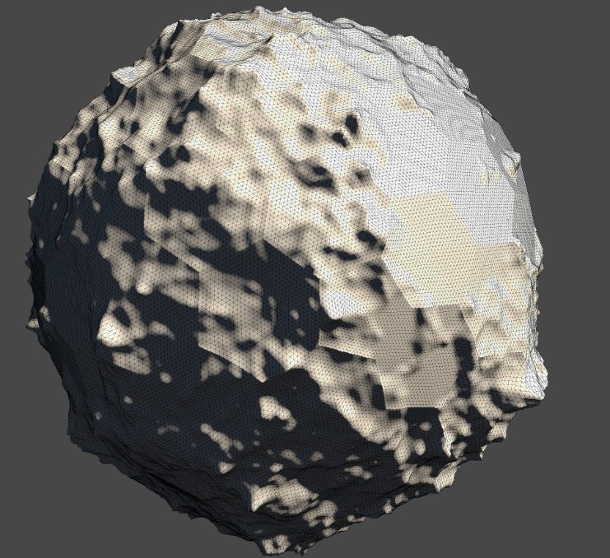
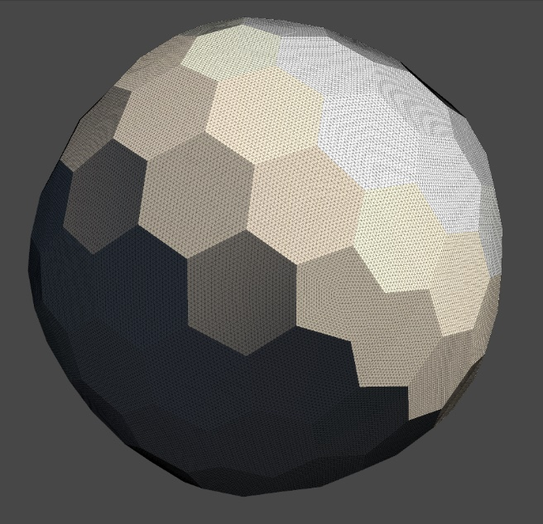
Figure 1 Example base shape
Figure 2 Example Terrain Generation

Contextual Analysis

Literature Review
Several algorithms have been put forward over the years to do this, the seminal paper common one is QSlim proposed in the 1997. Many algorithms developed since build upon QSlim, but other novel approaches have been developed since such as Multiple-choice Scheme and other.
As GPUs have gotten faster and more programmable over time, many GPU implementations of mesh simplification algorithms have written and improved upon to take advantage of the major parallelised performance advantages of GPU execution on large data sets like multimillion polygon meshes.
These algorithms have a dramatic time cost decrease compared to their CPU based implementations, especially on large meshes, making real-time simplification possible.
All of these algorithms are designed to work on arbitrary meshes usually pre-modelled objects from software like Blender, or Maya.

Critique of Related Work
All of these algorithms are designed to work on arbitrary meshes usually pre-modelled objects from software like Blender, or Maya.
Many have compared themselves to each other, or to the algorithm they are based on and built upon using a small range of different models of various sizes.
What there is a lack of research on is generated and terrain geometry in respect to a game’s application.
The reason why there may be a lack of research on could be because to reducing the geometry of a generate mesh is simple if you can control the resolution of the generation, just generate a lower resolution mesh. However, higher quality results should be achievable using simplification algorithms

Scientific Questions & Hypotheses
On a generated convex terrain mesh, does mesh simplification produce a low geometric error result than a lower resolution generation pass and which simplification algorithm A or B produces the lowest geometric error for the least compute time.
- Algorithms A and B should have a lower geometric error than a reduced resolution generated mesh
- Algorithm A should run faster than algorithm B
- Algorithm B should have a lower geometric error than algorithm A
- Algorithm A should have a better execution time per geometric error ratio than algorithm B

Methodology

Computing Artefact

Requirements and Data Format
To test the hypotheses a computing artefact that implements and can measure the performance of algorithm A and B must be created as well as this it must be able to generate a convex hull terrain mesh and multiple resolutions and with repeatable but randomizable results.
To save time, an existing terrain generating artefact will be reused, the data recording and algorithm implementation will be added into framework.
The variables being measured about each algorithm are the execution time of the algorithm and the quality of the result, expressed as geometric error. The geometric error is calculated using geometric deviation by comparing the simplified mesh to the high-resolution mesh.
As part of this experiment is trying to determine which algorithm works better with generated terrain meshes, more than one terrain mesh will be needed to ensure the better algorithm is always better. This can be done by randomly generating a seed which the terrain generation is based off, the seed used to generate the mesh will also need to be recorded.
To simplify the mesh using the algorithms, they need an additional input, how much to simplify the high-resolution mesh by. This is given as a % of the original Triangle count, to maximise the resolution of the test. Each algorithm will be tested using a set of reduction level.
Reduction Levels
75%
50%
25%
To compare the algorithms to just generating a lower resolution terrain, each terrain will also be generated at a lower resolution equal to the reduction levels used by the algorithms
A single Data entry element may look like this
Seed | Algorithm | Triangle Count | Reduction Level | Runtime | Geometric Error
1349123 | Algorithm A | 15m | 50% | 3000ms | 50%

A single test set may look like
Seed | Algorithm | Triangle Count | Reduction Level | Runtime | Geometric Error
1349123 | Terrain Gen | 15m | 75% | 300ms | 50%
1349123 | Terrain Gen | 15m | 50% | 30ms | 25%
1349123 | Terrain Gen | 15m | 25% | 3ms | 10%
1349123 | Algorithm A | 15m | 75% | 600ms | 75%
1349123 | Algorithm A | 15m | 50% | 60ms | 50%
1349123 | Algorithm A | 15m | 25% | 6ms | 25%
1349123 | Algorithm B | 15m | 75% | 1000ms | 95%
1349123 | Algorithm B | 15m | 50% | 100ms | 75%
1349123 | Algorithm B | 15m | 25% | 10ms | 50%

Data will be recorded as a csv file.

Detailed Breakdown of Operations
The artefact will test the algorithms through by first generate a high-resolution terrain mesh with N triangles.
The initial resolution will be a broadly configurable variable.
For each algorithm and for each reduction level, the artefact will run the algorithm using the high-resolution mesh as its input to create a simplified mesh, measuring how long it takes the algorithm to create the simplified mesh.
After creating the simplified mesh, the artefact will then compare the simplified result to the high-resolution mesh, by calculating a geometric error score, with 100% meaning identical in shape to the high-resolution mesh.
Finally, the artefact will create a csv entry, recording the terrain generation seed, the starting triangle count, the reduction level, the execution time and the geometric error.

Development Method(s)
Waterfall with meetings every two weeks

Ethical Considerations
The ethical concerns for this project end at the usage of the algorithms being tested within the paper from an IP perspective and the IP of the libraries, frameworks and tools used to carry out the experiment and analysis.
It is acknowledged that this is a computing experiment and so consideration for sustainability (energy usage) has been made, and deemed low as the proposed experiment can be run on a desktop computer, a high-power data centre is not necessary.
The overall ethical risk is low as this project does not involve human participants, or any significant legal issues. This research cannot be weaponised.

Data Management and Analysis Plan

Sampling

Control tests
Each algorithm will be test on a control generated mesh to determine its run-to-run variance in geometric error and execution. If run to run error is high for one or both algorithms, then during main data collection, each step can be repeated and averaged together as many times as needed to be confident.

Experiment Tests
To acquire data to answer each hypothesis, the artefact will start by generating a high-resolution terrain mesh at a specific polygon count (100k triangles). The seed to produce this mesh will be recorded.
Each algorithm will then simplify the high-resolution mesh to a range of steps 75%, 50% and 25% of the original polygon count.
The same will be done by the generation algorithm by making it regenerated the mesh at 75%, 50% and 25% of the original polygon count.
The time milliseconds it takes to simplify from the original to the step will be recorded.
After a simplified mesh has been created, the result will be compared to the original to determine the geometric error % of the simplified relative to the original mesh, using Geometric Deviation.
The geometric error of each algorithm will also be compared to running the generation algorithm at a lower resolution.

Data Analysis
Each hypothesis can be tested using a T test.
library(readr)
dat <- read_csv("H:Stats/tests_data.csv")
view(dat)
summary(dat)
t.test(x~y)
Figure 3 R code example

Summary of Future Work and Pathways to Impact
Maybe do a wider study?

Bibliography
See Zotero for now cos not made any citations.

